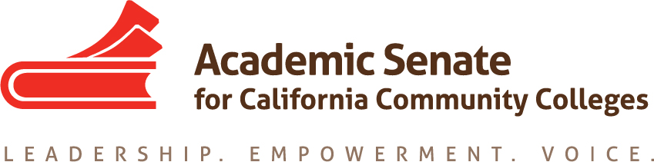

ONLINE EDUCATION COMMITTEE

Wednesday, 30 September 2015, 2:00 PM – 3:00 PM

CCC Confer

Participant Passcode: 231477
1-888-450-4821, http://www.cccconfer.org

Minutes

- Call to Order – 2:04pm
  - Members present: Gennean Bolen, Dolores Davison, Wheeler North, Joe Perret, Sanya Soyemi, Fabiola Torres, Laurie Vasquez

- Approval of August 26, 2015 minutes – approved

- Discussion items, with action as needed
  - Breakout for plenary – Hot Topics in Distance Education (Fabiola will be attending; Sanya and Gennean may be attending.)
    - Accreditation – what will the teams expect? What happens with the new standards? Information about what to expect as a campus, what questions will be asked by the team members, etc.
    - Accessibility – Laurie will provide updated information on this to include in the breakout
    - Authorization – discussion of SARA or other authorizations
    - First part of breakout will be accreditation, in conjunction with the Accreditation Committee, followed by a more broad conversation regarding current issues
  - IDI Breakout Ideas
    - OEI Update from the Faculty Perspective?
    - Lessons from Pilot Colleges?
    - High Touch and the MOOC Model
    - Academic Integrity in Online Courses: Models for Success
    - Classroom design and involvement of faculty
    - Integrated features in Canvas and other tools for faculty in both online and in person classes
    - Additional suggestions to be sent to Dolores by Friday to include in the discussion at Exec this weekend
  - Resolutions for plenary session – going to Exec this weekend
    - SARA authorization
    - Adoption of a course rubric
    - Regular, effective, substantive contact

    - Committee discussion about proprietary materials prompted interested in a resolution on guidelines on the usage of materials – Dolores will compose and distributed for feedback and walk into Exec on Friday
  - Online Ed Regionals –committee believes these are definitely necessary; structure similar to last year, with morning general session and then breakouts. Committee believes that 8-9 April will work. Laurie will check about holding them at her college in the south. Dolores will create agenda item and send it to committee for input and feedback. Possible breakout themes:
    - Professional Development
    - Accessibility
    - Accreditation and the new standards
    - Update on OEI and others initiatives around the state
    - Contact, effective practices, assessment
  - Rostrums (deadline = 12 October 2015)
    - Article on course design and rubrics
    - Others?

- Announcements
  - Executive Committee – October 2-3, Mira Costa College/Hilton Resort and Spa
  - Executive Committee – November 4, Marriott Irvine
  - Fall CTE Regionals – October 9, American River College
October 10, Irvine Valley College
October 16, College of Alameda
October 17, Modesto College
  - Area Meetings – October 23, North (Clovis and Evergreen Valley)
October 24, South (LA Valley and College of the Desert)
  - Fall Plenary – November 5-7, Marriott Irvine
  - Curriculum Regional (North) – November 13, Solano College
  - Curriculum Regional (South) – November 14, Mt. San Antonio College
  - Instructional Design and Innovation – January 21-23, Riverside Convention Center

- Adjournment – 3:00pm

