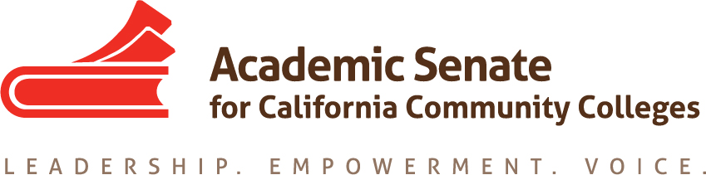

ONLINE EDUCATION COMMITTEE

Wednesday, 30 September 2015, 2:00 PM – 3:00 PM

CCC Confer

Participant Passcode: 231477
1-888-450-4821, http://www.cccconfer.org

AGENDA

- Call to Order

- Approval of the Agenda and Selection of Note taker

- Approval of August 26, 2015 minutes

- Discussion items, with action as needed
  - Breakout for plenary – Hot Topics in Distance Education
    - Accreditation
    - Accessibility
    - Authorization
  - IDI Breakout Ideas
    - OEI Update from the Faculty Perspective?
    - Lessons from Pilot Colleges?
    - High Touch and the MOOC Model
    - Academic Integrity in Online Courses: Models for Success
  - Resolutions for plenary session – going to Exec this weekend
    - SARA authorization
    - Adoption of a course rubric
    - Regular, effective, substantive contact
  - Rostrums (deadline = 12 October 2015)
    - Article on course design and rubrics
    - Others?

- Announcements
  - Executive Committee – October 2-3, Mira Costa College/Hilton Resort and Spa
  - Executive Committee – November 4, Marriott Irvine
  - Fall CTE Regionals – October 9, American River College
October 10, Irvine Valley College
October 16, College of Alameda
October 17, Modesto College

  - Area Meetings – October 23, North (Clovis and Evergreen Valley)
October 24, South (LA Valley and College of the Desert)
  - Fall Plenary – November 5-7, Marriott Irvine
  - Curriculum Regional (North) – November 13, Solano College
  - Curriculum Regional (South) – November 14, Mt. San Antonio College
  - Instructional Design and Innovation – January 21-23, Riverside Convention Center

- Adjournment

