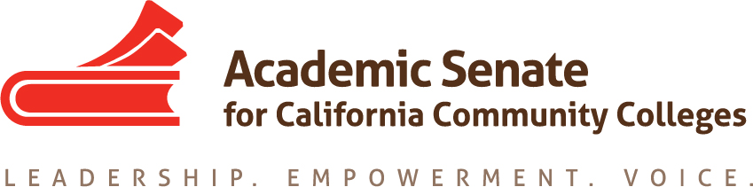

Online Education Committee

January 28, 2019

7:00am to 8:00am

Zoom Meeting

Minutes

In attendance: Anna Bruzzese, Geoffrey Dyer, Michael Heumann, Julie Oliver
Absent: Cathy Fernandez, Leticia Hector

- Welcome
At 7:00am, Geoffrey Dyer (Chair) welcomed the committee, and members present checked in briefly about the beginning of their fall semesters.

- Status of Previous Action Items
  - 9.03 S18 Effective Practices in Online Communication Courses
    - Survey results
The Survey results have been shared at Fall 2018 Plenary, and the .PPT from the breakout is posted on the Plenary webpage and the Online Ed committee page. The committee discussed reaching out to respondents who indicated they didn’t mind being contact for more information to inform future efforts, especially the 10% of respondents who indicated that they had taught an oral communication class online.
    - Deliverable by Spring Plenary, 2019
The committee discussed the possibility of a Rostrum article and Plenary breakout that could address the survey results and share effective practices to more fully meet this resolution.

  - 9.04 S18 Effective Practices in Online Lab Science Courses
    - Survey Results
The committee reviewed the survey results and remarked on how many faculty felt that their discipline was not adaptable to online education. The committee reflected on specific responses addressing safety, collaboration, and observation in lab sciences courses. The committee agreed to look more closely at individual responses to identify disciplines in which there was little or no objection from respondents to the possibility of delivering lab courses online and following up with respondents who indicated they were open to being contacted again to inform a possible breakout and Rostrum article.
    - Deliverable by Spring Plenary, 2019
The committee agreed to the strategy of sharing the results of both surveys and gathered follow-up feedback in a Rostrum article to be submitted by March 4 and to plan to include or reference them in a breakout at Spring Plenary 2019.

  - 11.01 S17 Using Savings from Adopting Canvas
The committee agreed this was not as pressing a priority as Resolutions 9.03 S18 and 9.04 S18. Geoffrey Dyer conveyed that it might be useful to refer to this resolution again, given the updated Title 5 section 55208, which stipulates that
instructors of distance education courses be prepared to teach in DE modalities in accordance with locally negotiated agreements.

- New action item: 9.03 F18: Local Adoption of the CVC-OEI Course Design Rubric
The committee reviewed Resolution 9.03 F18 and discussed how Imperial Valley
College, American River College, Pierce College, and Cosumnes River College are approaching online course review in different ways. Micheal Heumann shared components of the process of online course review at Imperial Valley College, which were for all DE courses. Geoffrey Dyer shared information provided by Pamela Bimbi at American River College about professional development linked to the rubric and ARC’s process to develop local POCR. Julie Oliver raised questions about how CVC-OEI would certify local POCR processes for courses going into CVC-OEI (badged). Geoffrey Dyer suggested that members of the committee request a CVC-OEI Advisory Committee Agenda Item and/or reach out to CVC-OEI project staff to further discuss what this process might look like as it continues to advance, specifically in terms of what CVC-OEI will expect from local POCR teams reviewing courses for CVC-OEI. The committee agreed that colleges would like options in how they apply the rubric and continue to strive to improve their online course offerings.

- Status of Distance Education Regulatory Changes
Geoffrey Dyer shared that the changes to Title 5 sections 55200-55208 still have not been published and are not yet appearing on Westlaw. The committee reviewed that the changes include assuring the regular and effective contact and accessibility requirements are addressed in the separate distance education addendum to the course outline of record. Geoffrey said that he, Cheryl Aschenbach, and Conan McKay submitted a Rostrum article on the regulatory changes and said that he would keep the committee apprised of when the updates are published.

- Update on California Online Community College
Geoffrey Dyer shared that ASCCC President John Stanskas has regularly been attending meetings of the COCC’s Board of Trustees and speaking to the need for Academic Senate voice on academic and professional matters. Geoffrey shared that the COCC has contracted the F3 firm to create Board Policies, and that John Stanskas had spoken to Academic Senate purview. Geoffrey shared that John Stanskas is appointing a group of faculty to review board policies which deal with 10+1 matters for the COCC. Julie Oliver asked if the CEO for the COCC had yet been appointed. Geoffrey said no and reported that some staff have been hired, including one in the capacity of an instructional designer.

- Spring 2019 Plenary: April 11-13, San Francisco
Geoffrey Dyer thanked the committee for the breakout ideas related to online education that they helped generate and said that he would report back once breakouts were approved and assigned. The committee did not identify any potential resolutions, but Geoffrey asked the committee to consider any potential resolution ideas in advance of February 22, the pre-session resolutions deadline for ASCCC committees.

- Scheduling of Next Meeting
Those present agreed that Tuesday, February 26th at 3:00pm would work for the next
meeting. Geoffrey Dyer said he would reach out to those who were absent in an effort to confirm the time and follow-up with additional possible times if necessary.

- Announcements
  - Events

The committee adjourned at 8:04am

