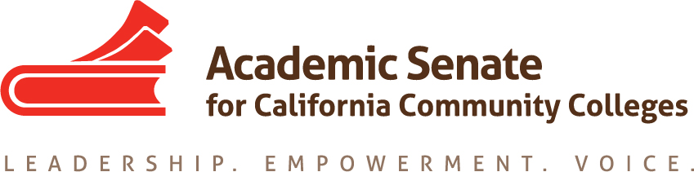

Part-time Committee
Thursday, November 19, 2020
11:30 a.m.—1:00 p.m.
Zoom Meeting
Join from PC, Mac, Linux, iOS or Android: https://cccconfer.zoom.us/j/98548427963
Or iPhone one-tap (US Toll): +16699006833,98548427963# or +13462487799,98548427963#
Or Telephone Dial:
+1 669 900 6833 (US Toll)
Meeting ID: 985 4842 7963

AGENDA
The part-time faculty committee provides recommendations to the Executive committee on academic and professional matters that affect part-time faculty members. The committee recognizes that part-time faculty make up the majority of California community college faculty and serve disproportionately-impacted students. This committee advocates for diverse part-time faculty colleagues, ensuring their access to professional and leadership development offerings as well as shared governance opportunities at the local and statewide levels. The part-time faculty committee collaborates with the executive committee to develop and provide opportunities where part-time faculty gain additional insight on issues germane to academic and professional needs. This committee is also focused on promoting diversity within part-time faculty pools with the goal of having educators who reflect the student population, and this committee further commits to empowering part-time faculty voices who have been historically excluded (e.g., colleagues of color).

- Members Roll Call:

Michelle Bean—Chair | Grace Chee | Alpha Lewis
Karen Chow—2nd Chair | Chelsea Hull | Emilie Mitchell
Steven Chang | Theodore Kagan | Luis Zanartu

- Call to Order and Agenda Adoption (Google Shared Folder)

- Minutes
  - Volunteer
  - October Summary Approval

- Shout Outs, Affirmations, and Lean-in
  - Community norms: empathy, communication, responsibility
  - Part-time Committee charge approved by Exec—cheers to us!
  - Thank you for completing the institute session descriptions!

- Part-time Institute: February 18-19, 2021 (virtual)
  - Institute Outline approved
    - Name change to Part-time Faculty Conference will happen for 2022
    - President Davison approved the consideration of conference proceedings e-publication—will need a lead volunteer to create a call to presenters for papers
    - All co-presenters approved on current institute outline—taking no other outside ASCCC presenter requests
  - Breakout session titles, descriptions, and presenters verified through email on Nov 16
    - Session leads—please communicate with co-presenters and ensure they register (free event); and plan meeting(s) to design session slides
    - Option—use Google slides template to work with co-presenters; slide decks due one week before the event
    - Save the date: virtual platform (Pathable) training for presenters will be on Feb 2 or Feb 3
  - Any other ideas or questions?

- Committee Goals and Priorities--review PTC work plan
  - See the workplan for your assigned actions
  - Regionals in spring?—CV review component and mentoring
  - Other ideas: Google unofficial listserv volunteers (Chelsea and ?)

- Plenary Fall 2020 Review
  - Break-out sessions recap and success
    - Mentorship Programs as a Recruitment and Retention Strategy of Faculty of Color (Chelsea)
    - Introduction to ASCCC Model Hiring Principles and Practices Canvas Tool (Emilie)
  - Increasing PT faculty participation
    - Will send Plenary survey data when received from ASCCC office (Michelle)
    - How did Caucus participation go for PT faculty? (Emilie)
  - PTC Resolution 1.02 (Steven)—click Adopted Resolutions packet for all passed resolutions

- Rostrum
- Click HERE for fall Rostrum
- PTC Articles
  - Mentoring programs--Chelsie
  - Part-time voting rights and seniority rights—Grace and Luis
  - Email articles to Michelle before January 1
  - Length—average around 700 words but could be up to 1,500 words

- Announcements
  - Sign up for CCC Anti Racism Opportunity (due Nov 20)
  - Upcoming CCC LGBTQ+ Summit
  - Check for ASCCC upcoming events at here
  - Sign up for ASCCC listservs—Part-time listserv available
  - Forward Application for Statewide Service to peers
  - Use Amazon Smile (smile.amazon.com)—select Foundation of the Academic Senate for California Community Colleges

- Closing Comments
  - In Progress Review
  - Any other final comments or suggestions?

- Adjournment

In Progress:
- Part-time Institute Planning
- Rostrum articles: Mentoring Programs and PT Voting and Seniority Rights

Completed Tasks:
- Resolution Fall 2020 1.02: Develop a Resource to Communicate and Encourage Part-time Faculty Leadership
- Plenary sessions: Mentoring Programs and Hiring Principles Canvas Tool
- Rostrum article: Faculty recommendations to second level interviews—focusing on diversifying the faculty
- ASCCC President Special Plenary Invitation Email (on 9/29/20 to local senate presidents and part-time listserv)
- PTC Workplan and Goals
- Updated ASCCC Part-time Committee Charge

