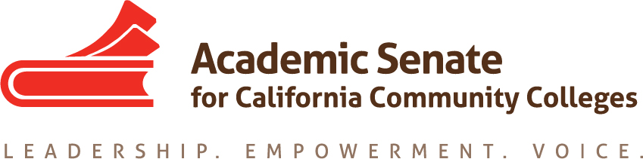

Part-time Committee
Thursday, September 24, 2020
11:30 a.m.—1:00 p.m.
Zoom Meeting
Join from PC, Mac, Linux, iOS or Android: https://cccconfer.zoom.us/j/98330513297
Or iPhone one-tap (US Toll): +16699006833,98330513297# or +13462487799,98330513297#
Or Telephone Dial:
+1 669 900 6833 (US Toll)
Meeting ID: 983 3051 3297

AGENDA
The Part-time Faculty Committee provides recommendations to the Executive Committee on academic and professional matters impacting part-time faculty members. The committee advocates for part-time faculty access to professional and leadership development offerings and shared governance opportunities at the local and statewide level. The Part-time Faculty Committee works collectively with the Executive Committee to develop and provide forums where part-time faculty gain additional insight on issues germane to academic and professional needs of the part-time faculty.

- Members Roll Call:

Michelle Bean—Chair | Steven Chang | Theodore Kagan
Karen Chow—2nd Chair | Grace Chee | Emilie Mitchell
Kym Andrews-Cardoza | Chelsea Hull | Luis Zanartu

- Call to Order and Agenda Adoption
Google Shared Folder

- Minutes
  - Volunteer
  - August Summary Approval
  - Contact List—check your info HERE

- Shout Outs, Affirmations, and Lean-in
  - Thank you all for the PTC charge quick feedback and beautiful perspectives!
  - So proud of us for our community norms: empathy, communication, responsibility.

- Committee Goals and Priorities
  - Resolutions assigned: Mentor Program
  - Develop PTC work plan and review ASCCC Strategic Plan
    - Institute
    - Regionals
    - Other ideas
    - Assigning actions

- Part-time Institute: February 18-19, 2021 (virtual)
  - Attendance
  - Review past event surveys in our Google folder
  - Theme Ideas: click HERE to add to Padlet
  - Institute overview paragraph due Sept 30
  - Institute Outline Drafting—due Oct 16
  - Session Break-out Ideas—descriptions and presenters due Nov 16
  - Any other ideas

- Plenary Fall 2020
  - Theme: Addressing Anti-Blackness: Inclusion, Diversity, Equity, and Antiracism in Academic and Professional Matters
  - Break-outs
  - Ideas on increasing participation
    - Foundation Scholarships—16 available
    - Email or other ideas
  - Resolution

- Announcements
  - Check for upcoming events at here
- Academic Academy (October 8-9)
- Area Meetings (October 16 and 17)
- Plenary (November 5-7)
  - Sign up for ASCCC listservs
  - Application for Statewide Service
  - Amazon Smile (smile.amazon.com)—select Foundation of the Academic Senate for California Community Colleges

- Closing Comments
  - In Progress Review
  - Any other final comments or suggestions?

- Adjournment

In Progress:
- Rostrum article: Faculty recommendations to second level interviews—focusing on diversifying the faculty
- PTC Workplan and Goals
- Part-time Institute Theme and Planning

Completed Tasks:
- Updated ASCCC Part-time Committee Charge
- Resolution Fall 2020 1.02: Develop a Resource to Communicate and Encourage Part-time Faculty Leadership

