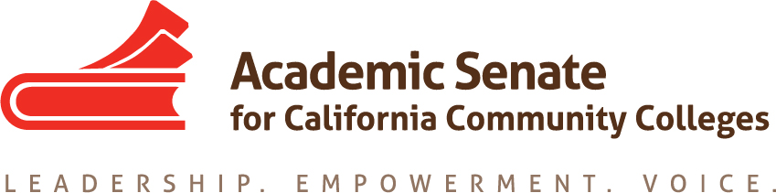

Part Time Committee

Friday August 31st, 2018

3:00 PM – 4:30 PM

Join from PC, Mac, Linux, iOS or Android: https://cccconfer.zoom.us/j/3285687631

Or iPhone one-tap (US Toll): +14086380968,3285687631# or +16468769923,3285687631#

Or Telephone:

Dial:

+1 408 638 0968 (US Toll)

+1 646 876 9923 (US Toll)

Meeting ID: 328 568 7631

- Order of the Agenda
- Welcome and Introductions
- Review of Committee Charter

The Part-time Faculty Committee provides recommendations to the Executive Committee on academic and professional matters impacting part-time faculty members. The committee advocates for part-time faculty access to professional and leadership development offerings and shared governance opportunities at the local and statewide level. The Part-time Faculty Committee works collectively with the Executive Committee to develop and provide forums where part-time faculty gain additional insight on issues germane to academic and professional needs of the part-time faculty.

- Review of Assigned Resolutions
- Part Time Faculty Leadership Institute – February 22nd – 23rd, 2019 (Newport Beach, CA)
- Possible Regional Meetings
- Future Meeting Dates
- Other

