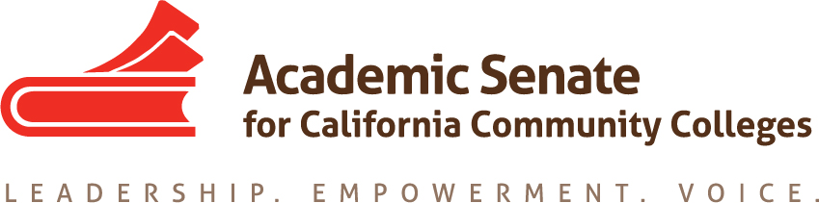

Standards & Practices Committee

Monday, August 26

6:30pm to 8:00pm

Join from PC, Mac, Linux, iOS or Android: https://cccconfer.zoom.us/j/721475012

Or iPhone one-tap (US Toll): +16699006833,721475012# or +16468769923,721475012#

Or Telephone:

+1 669 900 6833 (US Toll)

+1 646 876 9923 (US Toll)

Meeting ID: 721 475 012

International numbers available: https://zoom.us/u/adWsU2CQ5G

AGENDA

- Call to Order and Selection of Note Taker
- Welcome and Introductions
- Meeting Calendar
- Review Committee Charge:

The Standards & Practices Committee is charged with reviewing, acting on, and monitoring various activities as needed and assigned by the President or the Executive Committee of the Academic Senate. The Standards & Practices Committee's activities include, but are not limited to, conducting Disciplines List hearings, monitoring compliance with the Full Time/Part Time Ratio (75/25 rule), reviewing the faculty role in accreditation, screening faculty Board of Governors applications, analyzing and reviewing suggested changes in Executive Committee policies and Senate Bylaws and Rules, and administering designated awards presented by the Academic Senate. As assigned by the President or Executive Committee, the committee chair or designee will assist local academic senates with compliance issues associated with state statutes and their implementation.

- 2019 ASCCC Goals
  - Review Elections Processes
    - Pre-session Resolutions
  - Evaluate Second Minimum Qualification for Faculty

- CTE MQ Toolkit
  - What professional development does field need?

- Disciplines List—Proposals Due September 30
  - Annual Process

- Awards
  - Exemplary Program Award—Applications Due November 4, 2019
  - Hayward Award—Applications Due December 13, 2019
  - Stanback-Stroud Diversity Award—Applications Due February 14, 2020

- Committee Priorities

- Announcements
  - Events

- Adjournment

