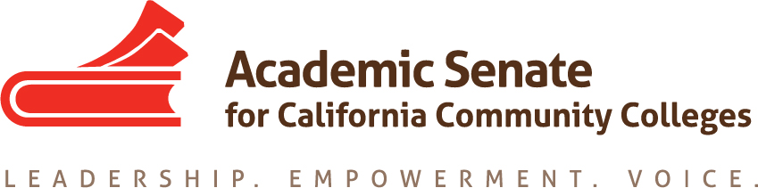

Standards & Practices Committee

September 16

6:30pm-8:00pm

Zoom: https://cccconfer.zoom.us/j/945911717

AGENDA

- Welcome

- Review Committee Charge:

The Standards & Practices Committee is charged with reviewing, acting on, and monitoring various activities as needed and assigned by the President or the Executive Committee of the Academic Senate. The Standards & Practices Committee's activities include, but are not limited to, conducting the Disciplines List revision process; analyzing and reviewing suggested changes in Executive Committee policies, Academic Senate Bylaws, and Rules; administering designated statewide faculty awards presented by the Board of Governors and the Academic Senate; and reviewing and recommending revisions to all processes under its purview as needed. The Standards and Practices Committee also provides professional guidance and technical assistance regarding faculty minimum qualifications and equivalence to the minimum qualifications.

  - Does an SSCCC Representative or representative of other charge need to be added to charge?
  - Potential to invite representatives of CIO and ACHRO when S&P discusses certain topics

- Disciplines List Revisions
  - Process
    - Disciplines List Revisions Handbook
      - Definition of Professional Organization
    - Summary Document for Area Meetings, October 11 and 12
    - Disciplines List Hearing: Nov. 7, 5:30pm, Renaissance Newport Beach Hotel
  - Current Submissions
    - Film Studies
  - Recent Inquiries
    - Learning Assistance or Learning Skills Coordinators or Instructors, and Tutoring Coordinators
    - Registered Behavioral Technology

- Awards
  - Exemplary Program Award—Applications Due November 4, 2019
  - Hayward Award—Applications Due December 13, 2019
  - Stanback-Stroud Diversity Award—Applications Due February 14, 2020

- 2019 ASCCC Goals
  - Review Elections Processes
    - Pre-session Resolutions
    - Rostrum Article due September 27

  - Evaluate Second Minimum Qualification for Faculty
    - Coordinate with Educational Policies Committee, ACHRO, and CIOs

- CTE MQ Toolkit
  - Co-coordinate professional development opportunities with CTE Leadership Committee
    - Target audience
    - Needs assessment—what, other than the toolkit itself, could we provide
    - Possible Dates and projected costs

- Committee Priorities

- Plenary

- Meetings Schedule:

  - Fall Zoom Meetings: October 21, November 25, and December 16 at 6:30pm.
  - Best Day and Time for Spring Meetings
  - Face-to-face Meetings

