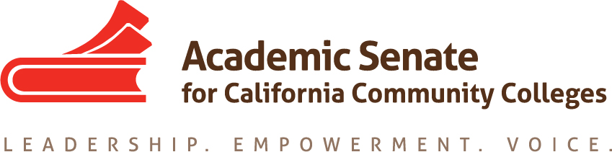

Standards & Practices Committee

1/28/19

4:30 pm – 5:30 pm

SUMMARY

- Call to Order and Selection of Note Taker – Cheryl Aschenbach & Erik Reese
Present: Erik Reese, Rebecca Eikey, Michael Berke, Cheryl Aschenbach
- Approval of Meeting Summaries –approved by consensus
  - November 26, 2018
- Hayward Award Reading
The scores are due Feb 11th. Recall, we discussed in August that there were problems with the rubric for the Hayward Award now that the award no longer is given per Area. We decided status quo on the rubric so we could learn ourselves what the exact issue is. Please take notes as you are using the rubric so we can discuss potential changes in the rubric for next year.
The rubric will be discussed at the next meeting of S&P.

- Updates
  - Policy 40.00 Honoring Faculty Leaders
This revised policy was approved by the Executive Committee in January 2019. The update was discussed briefly.

  - Revision of Handbook Revision – F16 10.01 Annual Consideration of the Disciplines List Proposals – Approved by Executive committee in January 2019.
The Handbook has been revised and will be posted in early February for the next cycle of the Disciplines process.

  - Senate Rules – revision to elections process
These were to be discussed a second time in ASCCC Executive Committee meeting in February.

  - Exemplary Program Award Update: Theme “Environmental Responsibility.”
In January, the Board of Governors honored the following programs.
Winner: Rio Hondo College – Alternative Fuels Program
Honorable Mentions:
a)Riverside City College – Urban Farm
b)Santa Barbara City College – Permaculture Garden
c)Sierra College – Environmental Studies and Sustainability (ESS)
Update provided on the winners of this award.

- Equivalency Regional Meetings for Spring 2019
  - Workshops similar to 2017 Curriculum Streamlining
    - Sacramento/NFN Region
    - Bay Area
    - Central Valley
    - LA/OC (may need to split)
    - Inland Empire
    - San Diego
No sites have been selected yet. These may be scheduled in March-April. With the intent of having smaller regional meetings of 35-45 people/session.
  - Desired outcomes:
    - to promote and improve the use of Equivalencies in the state – provide teams with effective equivalency practices and to examine their own practices for possible improvements
    - to promote use of CTE MQ&E Toolkit
The goal is to be hands-one and have teams that include Senate Presidents, MQ&E Charis, HR staff and CTE Deans. The CTE toolkit should be finalized in May

  - Strong Work Force Recommendation #13 (increase pool of qualified CTE instructors by addressing CTE faculty recruitment and hiring practices)
  - F16 Resolution – Posting of Equivalency Processes on Website
  - Review use of experience – several resolutions on this one
These items were included as part of the possible planning of the regionals.

- Spring Plenary General & Breakout Sessions Planning
  - Discipline Hearing & Resolution (Homeland Security)
  - Breakout Session ideas
    - MQ&E and Impact on Diversity
    - CTE MQ&E - Update on Toolkit and work of CTE Taskforce
The committee discussed how some MQ’s may be outdated and need revised. Thus, maybe this could be weaved into a Breakout session.

- Frequency of Surveys & Disseminating Information.
Follow Up: The Standards and Practices Committee to bring recommendations in the fall to the Executive Committee about the survey creation process and analysis and dissemination of the results.”
The committee discussed privacy concerns and determining which surveys are approved by Executive Committee. Rebecca will follow up with senior members and ASCCC office to have a better understanding of the process.

- Status of *Committee Priorities for 2018-2019
We have one completed item: Discipline Handbook.

- S&P Meeting Dates
    - February 25th, 4:30 pm – conflicts with Faculty Hiring Regional
    - March 25th, 4:30 pm – conflicts with spring break?
Committee decided to keep this date/time.
    - April 22nd, 4:30 pm

- Adjournment

Committee Charge
The Standards & Practices Committee is charged with reviewing, acting on, and monitoring various activities as needed and assigned by the President or the Executive Committee of the Academic Senate. The Standards & Practices Committee's activities include, but are not limited to, conducting Disciplines List hearings, monitoring compliance with the Full Time/Part Time Ratio (75/25 rule), reviewing the faculty role in accreditation, screening faculty Board of Governors applications, analyzing and reviewing suggested changes in Executive Committee policies and Senate Bylaws and Rules, and administering designated awards presented by the Academic Senate. As assigned by the President or Executive Committee, the committee chair or designee will assist local academic senates with compliance issues associated with state statutes and their implementation.

