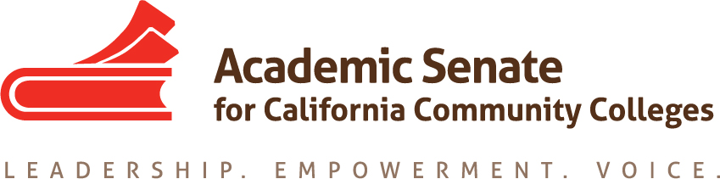

Standards & Practices Committee

4/22/19

4:30 pm – 5:20 pm

SUMMARY

- Call to Order and Selection of Note Taker
Present: Rebecca Eikey, Erik Reese, Cheryl Aschenbach
Absent: Michael Berke, Adrienne Foster, Jorge Ochoa, Kim Perigo

- Approval of Meeting Summaries
  - March 25, 2019 – by consensus
- Updates
  - Frequency of Surveys & Disseminating Information New Policy
  - Awards Handbook
  - Exemplary Program Award Theme = Student Support Services

The above items were approved by ASCCC Executive Committee meeting on April 10, 2019.

- Equivalency Regional Meetings for Spring 2019
The Academic Senate for California Community Colleges will be hosting a CTE Minimum Qualification Meeting.

In response to Strong Work Force recommendation #13, which focused on the use of equivalency to increase hiring pools of qualified CTE instructors, the Chancellor’s Office CTE Minimum Qualifications Workgroup has developed an Equivalency Toolkit. The Toolkit is a collection of resources that colleges, HR officers, deans, and faculty can use to improve and promote the use of equivalency in hiring and that applicants can use to better understand and navigate equivalency processes. Join representatives of the workgroup to explore the toolkit and to discuss effective practices for equivalency processes.
      - Los Rios District, April 29 – Cheryl Aschenbach, Rebecca Eikey & Lynn Shaw
      - Los Angeles Technical Trade, May 2 – Rebecca Eikey & Lynn Shaw
      - Reedley College, May 3 – Cheryl Aschenbach & Lynn Shaw
      - Moorpark College, May 8 – Rebecca Eikey & Lynn Shaw

The committee discussed the format of the Regional meetings, updates to the presentation based on feedback at Plenary and ideas to disseminate the Toolkit, such as a Canvas Page.

- Concluding Work of the Committee
  - Mission, Vision, Values
There are a number of notes taken from the Spring Plenary Breakout on the need to revise the Values for the organization, incorporate the diversity statement into the values, revise the mission statement and create a vision statement.

Committee suggests an agenda item to Executive Committee for clarification on the next steps.

  - Status of Committee Priorities for 2018-2019
The committee reviewed and updated the spreadsheet related to the priorities. There are a number of resolutions related to apprenticeship and internships that could be addressed next year.

  - Policy Renumbering
https://docs.google.com/document/d/1vVymCfT4RwuQYvzmnKv5h3vGtF9D8MOQDyuqTCYkTD0/edit?usp=sharing

There were recommendations of 4 categories and numbering suggested related to those: HR, Compensation, General, Other

- Adjournment

Committee Charge
The Standards & Practices Committee is charged with reviewing, acting on, and monitoring various activities as needed and assigned by the President or the Executive Committee of the Academic Senate. The Standards & Practices Committee's activities include, but are not limited to, conducting Disciplines List hearings, monitoring compliance with the Full Time/Part Time Ratio (75/25 rule), reviewing the faculty role in accreditation, screening faculty Board of Governors applications, analyzing and reviewing suggested changes in Executive Committee policies and Senate Bylaws and Rules, and administering designated awards presented by the Academic Senate. As assigned by the President or Executive Committee, the committee chair or designee will assist local academic senates with compliance issues associated with state statutes and their implementation.

