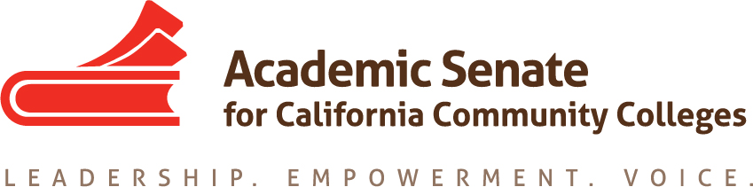

Standards and Practices Committee

Friday February 13th, 2015

9:00AM – 11:00 AM

Members Present: A. Juarez, C. Rutan, P. Setziol, J. Bruno, J. Adams, A. Foster

Members Absent: P. Crawford

Meeting called to order at 9:03 AM.

- Order of the Agenda: The agenda was approved as presented.
- Approval of the Minutes from 1/17/15: Minutes from the meeting on 1/17/15 were approved as presented.

- Update on ASCCC Open Meetings Policy: C. Rutan reported that a draft of the Open Meetings Policy that was originally going to be reviewed at the 2/13/15 meeting of S&P was brought forward to the Executive Committee for discussion and adoption on February 6, 2015.

- Procedures and Criteria for Norbert Bischof Faculty Freedom Fighter (NBFFF) Award: S & P reviewed the proposed criteria for nominations and selection of winners of the NBFFF. The procedures will be presented for adoption at the April Executive Committee meeting at Berkeley City College.

- Policy for Removal of a Member of the Board of Directors: C. Rutan presented a draft of the policy specified in the bylaws revisions. The policy was developed using the document created by P. Crawford using Robert’s Rules of Order and the Senate’s ethics policy. P. Setziol suggested that the policy should be revised to clearly indicate when the policy applied. J. Bruno will send C. Rutan the suggested revisions and this will be submitted for adoption at the March Executive Committee meeting.

- Executive Committee Survey for Periodic Evaluation of ASCCC: The Periodic Review of ASCCC requires the Executive Committee to create an internal evaluation that will be provided to the review team. J. Adams has compiled a draft evaluation survey based on similar surveys used by other nonprofit boards. P. Setziol will review the wording on the survey and adjust it to align with the language typically used by the Senate. The survey will be reviewed by the Executive Committee at the March meeting and will be finalized at the March 24th S&P meeting.

- Survey for Update of Equivalency Paper: P. Setziol and J. Bruno presented a draft survey to update the equivalency paper. A. Foster voiced concern that the survey does not currently deal with multi-college districts where equivalency may be a district level function. A. Foster and P. Setziol will review and revise the survey to incorporate multi-college districts and district-wide coordination on equivalency. The survey will be reviewed and finalized at the March 24th S&P meeting.

- Resolution for Local Senate Awards Monitor: Following the lack of applications for the Hayward Award, A. Juarez and P. Setziol drafted a resolution encouraging local senates to designate a senator or committee to monitor statewide faculty awards to ensure that the magnificent work being done by faculty is recognized. J. Bruno and C. Rutan will perfect the language in the resolution and C. Rutan will forward the resolution to the Resolutions Chair for inclusion with the Executive Committee Resolutions.

- S&P Breakout Assignments for Plenary
  - Bylaws/Rules/Periodic Evaluation of the Academic Senate: C. Rutan and J. Adams will present this breakout. C. Rutan encouraged other members of S&P to attend the session. The session will summarize the revisions to the Bylaws, Rules, and the upcoming Periodic Review of ASCCC.

  - Minimum Qualifications and Equivalency: A. Foster and P. Setziol will work on this presentation with C. Rutan. The presentation will include a discussion of eminence and the use of eminence in determining equivalency.

- Update on Collegial Consultation in the CCC: The statement on Collegial Consultation has been incorporated into the revised Local Senates Handbook that will be presented for adoption at the spring plenary session.

Meeting adjourned at 10:33 AM.

Respectfully submitted,

Craig Rutan

Approved on March 24th, 2015

