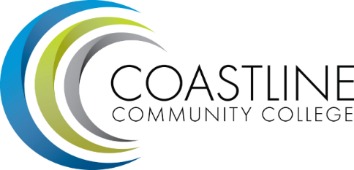

SLO Engagement Party

How does your college engage faculty through the SLO development and assessment process?

How frequently are discussions around SLO results held? In what venue are these discussions held (e.g., department meetings)?

List three activities that would inspire and promote engagement through the different stages of SLOs.

SLO Development | SLO Assessment | SLO Discussion and Planning
1.  2.  3. | 1.  2.  3. | 1.  2.  3.

