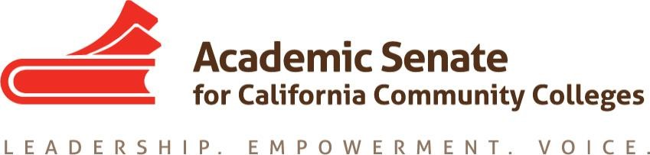

Faculty Leadership Institute 2019
Sheraton Grand Sacramento Hotel
Saturday, June 15, 2019

Senate Resources at Your Fingertips!

- Academic Senate for California Community Colleges (ASCCC or Academic Senate):
https://www.asccc.org

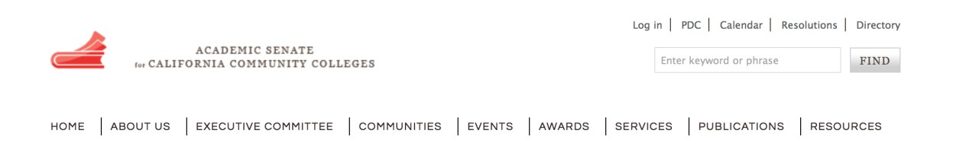
  - ASCCC: Subscribe to Newsletter: https://asccc.org/signup-newsletters

  - ASCCC Request for Services: https://asccc.org/contact/request-services

  - ASCCC Resolutions: https://asccc.org/resources/resolutions

  - ASCCC Legislative Positions: https://asccc.org/legislative-positions

  - ASCCC Application for Service: https://asccc.org/content/application-statewideservice

- Local Senates Handbook:
https://www.asccc.org/sites/default/files/local_senates_handbook2015-web.pdf

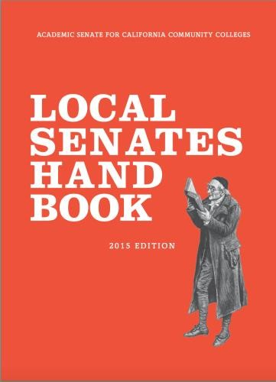

- Resolutions Handbook:
https://www.asccc.org/sites/default/files/ResolutionHandbookFinalFA17_1.pdf

Resolutions Operational Committee Webpage:
https://www.asccc.org/directory/resolutions-operational-committee

- California Community Colleges Chancellor’s Office (CCCCO or CO):
http://www.cccco.edu

- California Legislative Information: http://leginfo.legislature.ca.gov
Find your legislators: http://www.legislature.ca.gov/legislators_and_districts/legislators/your_legislator.html

- Community College League of California (CCLC): https://www.ccleague.org

- Accrediting Commission of Community and Junior Colleges (ACCJC): https://accjc.org

- Course Identification Numbering System (C-ID): www.c-id.net

- Senate publications (Academic Senate Papers, Rostrum, President’s Updates and others): https://asccc.org/publications

Scenarios…let’s get started…

- What is AB 1805? Where do you find information about AB 1805? Has it passed? Has it been amended?

- Where do you find the actual “collegial consultation” definition and Title 5 language?

- What positions has the ASCCC taken in regard to AB 705?

- Where does one access information related to Resolutions?

- You recently attended the Career and Noncredit Institute in April - where do you find the presentation materials?

- You would like to sign up for the Area A Listserv - how would you go about doing that?

- What is required for curriculum approval? Where do you find it?

- What burning questions do you have?

