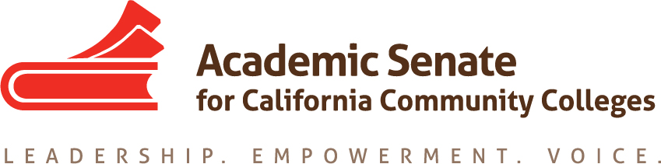

Transfer, Articulation and Student Services Committee

11 December 2019, 4 p.m.

Zoom

MINUTES

- Call to Order and Adoption of the Agenda
At 4:02 p.m. Sam Foster (chair) welcomed the committee members participating in today’s meeting: Anna Bruzzese, Lorraine Burnham-Levy, Mark Osea and Miles Vega.

Absent: Jose Lara

- Volunteer note taker
Anna volunteered to take notes.

- Update on Resolution 7.01 F17 Creating Guidelines for Veteran Resource Centers
  - Executive Committee feedback on proposed survey
The Executive Committee provided some feedback but also felt that maybe we don’t need a survey to get this information. A suggestion was made to reach out to colleges directly. Sam contacted Dolores to start the process of reaching out to VRCs about effective practices.
  - List of Community College VRCs (attached)
As the distributed list demonstrates, almost all colleges have a VRC already, except for one which is sharing a VRC with another college.

- Update on Transfer Paper
  - Review of draft
  - Timeline
    - Submit to Exec for First Read—Dec 12
    - Submit to Exec for Second Read—Feb 12
Sam has been working on combining all the information that committee members sent to him. He will make some additional edits before submitting the draft to Exec for first read. The committee talked about recommendations/conclusions, including adequate/stable funding and support for positions such as the Articulation Officer, as well as for Transfer Centers. Also, there is an issue of geography and distance from transfer institutions. The student to counselor ratio also continues to be a problem. This is linked to the FON and the 50% law. We also need to use counselors we have more effectively.

- Update on Survey on Open Educational Resources (OER)
There is no update on this item today. This item will remain on our agenda.

- Fall Resolutions Assigned to TASSC
  - 9.01 F19 Local Determination of International Baccalaureate Credit at California Community Colleges

There is concern regarding the urgency of this resolution. Sam reached out to John Stanskas, and John put Sam in touch with Cheryl Aschenbach from 5C. John said we could make recommendations that can inform 5C because 5C makes systemwide recommendations. Cheryl said that 5C has already been working on a related policy, but the work is not yet finished, and they welcome our input. The committee reviewed the resolution. This item will be on our agenda for January.

16.01 F19 Develop Standards of Practice Resource for Learning Assistance and Tutoring in the California Community Colleges, including the role of Learning Skills Coordinators or Instructors, and Tutoring Coordinators
The committee reviewed this resolution. The due date is July 30, 2021, so if we have time, we will develop some suggestions for next year’s committee.

- Future Meetings
  - In-Person Meeting January 30 at Rio Hondo College
  - Plan Meetings for spring semester—best times
The committee members talked briefly about their schedules and will plan its spring meetings during its January meeting.

- Other Items for Discussion

- Announcements/Events
  - Part Time Faculty Institute – Napa Valley – January 24, 2020
  - Accreditation Institute – San Diego – February 21, 2020

- Adjournment
The meeting adjourned at 5:15 p.m.

Minutes respectfully submitted by Anna Bruzzese.

