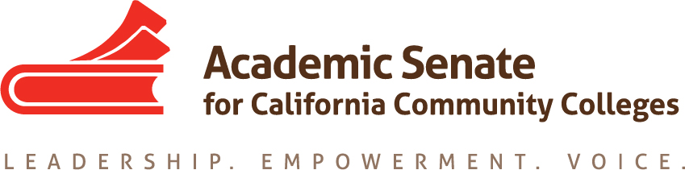

Transfer, Articulation and Student Services Committee

20 November 2019, 4 p.m.

Zoom

MINUTES

- Call to Order and Adoption of the Agenda
At 4:00 p.m. Sam Foster (chair) welcomed the committee members participating in today’s meeting: Anna Bruzzese, Jose Lara, Mark Osea and Miles Vega. The committee unanimously adopted the agenda.

Absent: Lorraine Burnham-Levy

- Volunteer note taker
Anna volunteered to take notes.

- Fall Plenary Breakout Session on Transfer Pathways Debrief
Sam, Jose, Lorraine and Craig Rutan co-presented on this topic at the Fall Plenary in Newport Beach. The presentation was interactive and went well, even though not all slides got covered. The audience had a lot of questions, in particular about the alignment of UC and CSU transfer pathways. Sam suggested that we may want to ask Craig to help us, especially with a section of the paper that deals with UC transfer pathways.

- Update on Resolution 7.01 F17 Creating Guidelines for Veteran Resource Centers
  - Updated survey questions (see attached)
Sam submitted the proposed survey to the ASCCC Executive Committee for their December
6-7 meeting. We will have their feedback by our committee’s next meeting on December
11.

- Update on Survey on Open Educational Resources (OER)
Sam reached out to Michelle Pilati to ask about what was needed and who should be consulted but did not get a clear answer/direction. One suggestion was that we need to know if anything about OER/low cost textbooks is included in the orientation. This will be put on our agenda for our December 11 meeting.

- Update on Transfer Paper
  - Review of preliminary draft
  - Timeline
    - Draft edits to chair—Dec 5
    - Submit to Exec for First Read—Dec 10
    - Submit to Exec for Second Read—Feb 12

Sam compiled the sections and sent it out to the committee members before today’s
meeting. The committee reviewed the current draft and discussed some currently missing

pieces: section III of the outline needs some additional information. We need something on
the support services. Jose will work on disability to support services. Anna will work on
section III a, Sam and Anna will tackle III f. Jose will tackle III b. Miles will take section III e
and g. Jose will also write something about AB 705 and its impact on the transfer center,
and Mark can talk about the impact of AB 705 on articulation and transferability of courses.
And, Jose will also discuss the impact of AB 705 on strengthening the transfer
path/completion. Mark will also expand the section on the role of the counseling faculty.
Jose also suggested referencing “Through the Gate” study in the introduction. Sam
mentioned Umoja and Puente as additional strategies and interventions that helped with
increasing transfer among underrepresented student populations. This would go under IV
b. This would also be linked to equity. Another thing to include in the introduction is the
Vision for Success. Sam went over the deadlines, the first deadline was changed from
December 2 to December 5.

- Future Meetings
  - Next Zoom meeting December 11 at 4 p.m.
  - In-Person Meeting January 30 at Rio Hondo College

- Other Items for Discussion
There were no additional items.

- Announcements/Events
  - Part Time Faculty Institute – Napa Valley – January 24, 2020
  - Accreditation Institute – San Diego – February 21, 2020

- Adjournment
The meeting adjourned at 5:05 p.m.

Minutes respectfully submitted by Anna Bruzzese.

