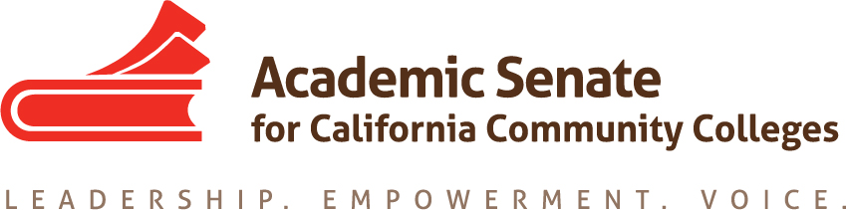

Transfer, Articulation and Student Services Committee

21 May 2020, 5 p.m.

Zoom

MINUTES

- Call to Order and Adoption of the Agenda
At 5 p.m. Sam Foster (chair) welcomed the committee members participating in today’s meeting: Anna Bruzzese, Jose Lara, Lorraine Burnham-Levy, Mark Osea, Miles Vega.

- Volunteer note taker
Anna volunteered to take notes.

- Check in
Committee members checked in with one another.

- Update on Transfer Paper
The most recent revised draft was submitted for the May Exec agenda. Our work on the paper is done. The paper will go to the editor before the paper gets final approval from the Executive Committee to go before the entire Academic Senate body for approval, hopefully at the Fall plenary.

- Update on Survey on Open Educational Resources (OER)
At this point this survey appears to be moot. Sam reached out to Michelle Pilati and she said the use of OER has increased.

- Update on Fall Resolutions Assigned to TASSC
The committee was unable to address the following resolutions, as we focused primarily on the transfer paper, so these would need to be addressed by next year’s committee.
  - 9.01 F19 Local Determination of International Baccalaureate Credit at California Community Colleges

16.01 F19 Develop Standards of Practice Resource for Learning Assistance and Tutoring in the California Community Colleges, including the role of Learning Skills Coordinators or Instructors, and Tutoring Coordinators - The committee felt that it would be best to develop resources rather than a paper but we will discuss this further next time.

- End of Year Report (see attached form)
The committee discussed the assigned priorities to determine which ones were completed, which ones are in progress and which ones have not been completed. Sam will submit the End of Year Report to the Executive Director Krystinne Mica on the committee’s behalf.

One of the suggestions for next year’s committee is to evaluate the effectiveness of wrap-around services in the wake of COVID-19, and to look for best practices since all colleges are now offering them. Another suggestion was to look at innovations at transfer centers to continue to provide transfer and counseling services and report them to the field.

- Acknowledgements!
The committee members expressed their appreciation for each other and everyone’s significant contributions throughout this academic year. Serving on this committee was a very positive experience for us all. Sam also reminded everyone to submit their application for statewide service for next year.

- Other Items for Discussion

- Adjournment

The meeting adjourned at 6 p.m.
Minutes respectfully submitted by Anna Bruzzese.

