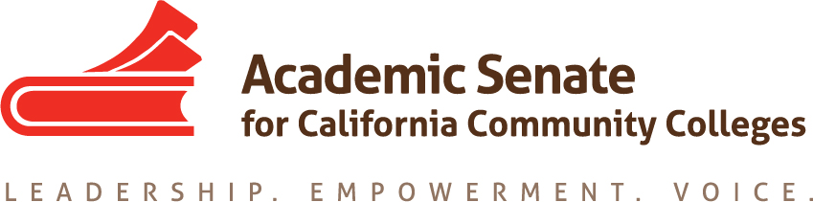

Transfer, Articulation and Student Services Committee

31 January 2020, 10 a.m.-3 p.m.

Rio Hondo College

3600 Workman Mill Road
Whittier, CA 90601

Transfer Center

Student Service Building Room 250

MINUTES

- Call to Order and Adoption of the Agenda
At 10:10 a.m. Sam Foster (chair) welcomed the committee members participating in today’s meeting: Anna Bruzzese, Jose Lara, Lorraine Burnham-Levy, Mark Osea and Miles Vega.

- Volunteer note taker
Anna volunteered to take notes.

- Planning for future meetings
  - Spring schedules and best times
The committee decided that the best meeting time would be on Thursdays at 5 pm. Next meeting will be on February 13th and the following meeting will be on March 12th.
  - Frequency of needed meetings
We will need at least two more meetings before submitting the final version by March 16.

- Breakout at CTE/ Noncredit institute
  - Topics on promising counseling practices for CTE and noncredit
  - Proposals due on February 7
  - Call for Proposals can be found at: https://docs.google.com/forms/d/e/1FAIpQLScVnA4_3MsQiLB2on6TmhGpG9uC4oG2g4XvE8gdbeszrLg3WQ/viewform

Sam explained that the committee was asked to participate. Lorraine and Mark volunteered
to work on a presentation.

- Update on Transfer Paper
  - Review of draft
  - Executive committee comments
  - Additional sources to consider as suggested by RP Group Liaison Jake Kevari
    - Completion by Design - Loss/Momentum Framework
    - Completion by Design - Building Guided Pathways
    - RP Group - Student Support (Re)defined - Six Success Factors
    - RP Group - Through the Gate March 2019 Update & Through the Gate Website
  - Other external references to consider
  - Editing draft
  - Timeline
    - Submit to Exec for Second Read—Feb 12
    - Final edits based on Exec recommendations—March 16

The committee reviewed the most recent draft of the paper and revised it further. The
committee agreed to add a section on high impact practices that support students and
developed a revised outline that was emailed to the committee members.

- Update on Resolution 7.01 F17 Creating Guidelines for Veteran Resource Centers
This item is postponed till the next meeting.

- Update on Survey on Open Educational Resources (OER)
There is no update on this item today. This item will remain on our agenda.

- Update on Fall Resolutions Assigned to TASSC
  - 9.01 F19 Local Determination of International Baccalaureate Credit at California Community Colleges

This item is postponed till the next meeting.

16.01 F19 Develop Standards of Practice Resource for Learning Assistance and Tutoring in the California Community Colleges, including the role of Learning Skills Coordinators or Instructors, and Tutoring Coordinators

The due date is July 30, 2021, so if we have time, we will develop some suggestions for next
year’s committee. This item is postponed till the next meeting.

- Other Items for Discussion
There were no other items for discussion.

- Announcements/Events
  - Accreditation Institute – San Diego – February 21, 2020
  - Area Meetings—Various locations—March 27-28, 2020
  - Spring Plenary Session—Oakland—April 16-18, 2020
  - Career and Noncredit Institute—San Mateo—April 30-May 2, 2020

- Adjournment
The meeting adjourned at 3:06 p.m.

Minutes respectfully submitted by Anna Bruzzese.

