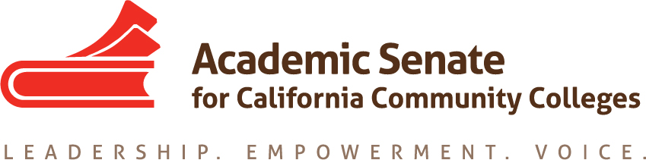

Transfer, Articulation, and Student Services Committee (TASSC)
April 11, 2016 – 12:00-1:30
CCC Confer
Dial your telephone conference line: 1-913-312-3202*
Presenter Passcode: 7141852
Participant Passcode: 904771
*Toll free number available: 1-888-886-3951

Minutes
Members Present: Ginni May (Chair), Dolores Davison (2nd), Vicki Maheu, April Pavlik, Trevor Rodriguez,
Shuntay Taylor, Michael Wyly

Members Absent:

- Select note taker – Dolores Davison

- Approval of the Agenda – Approved

- Approval of the Minutes from March 7, 2016 – done by email

- Academic Academy debrief
  - Very positive responses, especially about the conversations at the end of the institute
    - ASCCC will look at dates for future academies to ensure that they do not conflict with other events

- Spring Plenary Session 2016
- Who is going? – Ginni, Dolores, Shuntay, Michael, April, maybe Vicki
- Breakout from TASSC – Disenfranchised Students, Thursday, April 21, 3:45-5:00
  - Ginni will put together preliminary information; everyone should email her by Saturday; she will then email everyone on Sunday with a draft which will be completed and submitted on Monday.
- Spring Fling – Thursday, April 21, 6:30-9:30 at MIX Downtown; tickets still available
- Auction – need donations – Shuntay will donate wine
- ASCCC Elections: At-Large, South Rep, North Rep, Area C, Area B, all officers
- Resolution on AP Credit and AB 1985 (Williams) – Creation of some kinds of standards without legislation; legislation is aimed specifically at GE credit

- Survey and article on Services for Disenfranchised Students – Breakout at Plenary
Survey closed on April 7: https://www.surveymonkey.com/results/SM-X73LCNSW/
Disenfranchised Students—Who are They, How are we Helping Them, and What More Can We Do?
Adrienne Foster, ASCCC Executive Committee, West Los Angeles College
Vicki Maheu, San Diego Continuing Education
Ginni May, ASCCC Executive Committee, Sacramento City College
April Pavlik, Los Angeles City College
Shuntay Taylor, West Hills College, Lemoore
Michael Wyly, Solano Community College

During the Fall 2014 Plenary Session, the Academic Senate for California Community Colleges delegates passed Resolution 20.0, Developing a System Plan for Serving Disenfranchised Students. In response, the Transfer, Articulation, and Student Services Committee published an article describing some of our disenfranchised students for the February 2016 Rostrum and disseminated a survey among the California community colleges to ascertain the types of services provided for these students. During this breakout, we will review the resolution, discuss the characteristics of disenfranchised students, examine the preliminary results of the survey, and consider options in providing better services for these students.

- TASSC Meetings
- May 2, 12:00-1:30 (Monday)

- Future Agenda Items
-Academic Academy Evaluations
-Plenary debrief and going forward with disenfranchised survey
-Recommendations for next year’s committee

- Events
Noncredit Regionals – April 15 (North—TBA), April 16 (South—Mt. San Antonio College)
Spring Plenary Session – April 21-23, Sacramento Convention Center
CTE Institute – May 6-7, Double Tree, Anaheim
Faculty Leadership Institute – June 9-11, Riverside
Curriculum Institute – July 7-9, Anaheim

