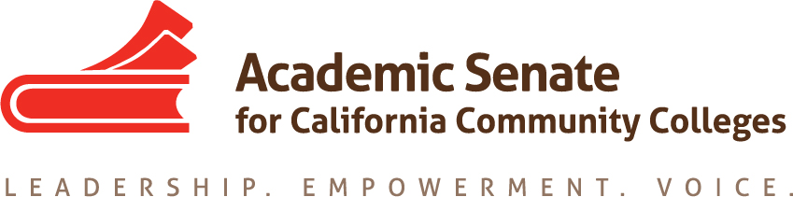

Transfer, Articulation and Student Services Committee

9 April 2020, 5 p.m.

Zoom

MINUTES

- Call to Order and Adoption of the Agenda
At 5 p.m. Sam Foster (chair) welcomed the committee members participating in today’s meeting: Anna Bruzzese, Jose Lara, Lorraine Burnham-Levy, Mark Osea and Miles Vega.

- Volunteer note taker
Anna volunteered to take notes.

- Check in - committee members checked in with one another.

- Update on COVID-19 impact on Transfer, Counseling, Other areas – Bakersfield College is holding virtual transfer fairs. Rio Hondo College is offering virtual counseling and communicating information regarding COVID-19 response at transfer institutions. Porterville College is offering mental health services for students. Colleges are also offering EW, Pass/No Pass and other options in order to minimize the impact of this pandemic on students’ ability to reach their educational goals.

- Update on Transfer Paper (attached) – Sam sent out the most recent version of the paper (version 4) to committee members before today’s meeting. Committee members discussed proposed changes. The goal is to have the revised draft by next Thursday to submit it for the May Exec agenda. Sam will send out the outline the committee revised today to everyone shortly.

- Update on Fall Resolutions Assigned to TASSC - We will look at these at the end of the semester to make recommendations for next year’s committee.
  - 9.01 F19 Local Determination of International Baccalaureate Credit at California Community Colleges

16.01 F19 Develop Standards of Practice Resource for Learning Assistance and Tutoring in the California Community Colleges, including the role of Learning Skills Coordinators or Instructors, and Tutoring Coordinators

- Other Items for Discussion

- Adjournment
The meeting adjourned at 6:40 p.m.
Minutes respectfully submitted by Anna Bruzzese.

