Zoom Events Prerequisites

Prerequisites for joining Zoom Events
- Zoom desktop client:
  - Windows: 5.7.6 or higher
  - macOS: 5.7.6 or higher
- Zoom mobile client
  - iOS: 5.7.6 or higher
  - Android: 5.7.6 or higher
- Zoom Events web browser:
  - Chromium Edge: 80 or higher
  - Google Chrome: 53.0.2785 or higher
  - Safari: 10.0.602.1.50 or higher
  - Firefox: 76 or higher
  - Internet Explorer: 10 or higher
Note: Microsoft has ended support for Internet Explorer (IE) 11 on August 17, 2021. Based on this date, Zoom has ended support for IE on September 30, 2021. Users can still use Zoom on IE after this date but we will no longer be supporting IE, fixing issues related to IE, or offering any customer support related to IE.
- Basic, Pro, Business, Enterprise, or Education account

Notes:
- There is a dependency with Windows' WebView package for Windows platform; while version 5.7.6 does support Zoom Events, it may cause a blank lobby experience for attendees.
- For attendee access to the latest Zoom Events and Webinar features, we highly encourage attendees to update to the latest version of the Zoom desktop client/mobile application.

Helpful Tips to Consider Navigating Zoom Events

- Please review the prerequisites above to see if your device is supported and use the email invitation you received to access the event hub.
- Sign in to Zoom only using the email you used to register for the event, which can be found in the Know Before You Go section of the email invitation. (Only this email will give you access to your ticket/event).
- Please note, if you have login/access to multiple zoom accounts, you must be logged out of those accounts in order to access the event. Those that are not properly logged in to the email in which they used to register for the event will receive and error message when trying to access the event hub.
- Zoom Events will allow you join the event from desktop computer’s web browser or your mobile device. We highly recommend attendees join the event only using a desktop web browser.
- The ASCCC Events team has provided step by step examples to access the Zoom events hub below.

Logging in to Zoom Events

Helpful Zoom Event Resources and Screenshots Navigating the Event Hub
- You will receive an email invitation from Zoom Events with information about the event link, your role(s), your email address login, and device updates.
- The direct link to access your ticket to the event hub can be found in your email invitation to the event. Once you click on the “View Event”, be sure to bookmark this so you can get easy access to resources and the full timeline of the schedule.

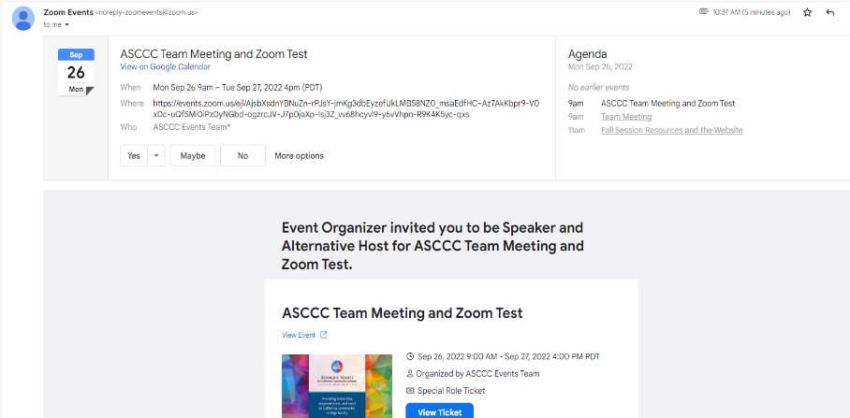
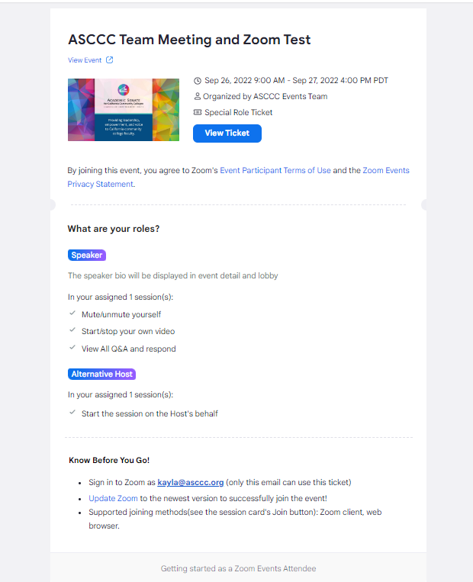

Know Before You Go
- It’s important to read the Know Before You Go to ensure you are logging in with the correct email address and update your Zoom to the newest version.
- Please note that the email address listed in the Know Before You Go section of the email is the only email that has access to Zoom Events. If the email address listed on there is incorrect or you would like to change it, you will need to reach out to events@asccc.org to correct the email address.

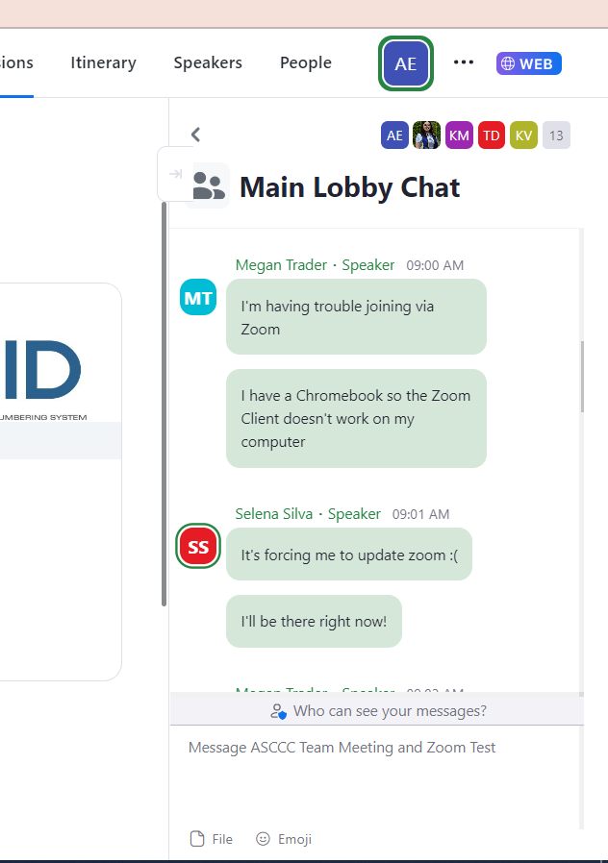
How to Use the Lobby Chat
- On the Lobby page, there will be a count-down to the event start time. In the meantime, attendees can use the Lobby Chat to communicate and dialogue with everyone.
- The Lobby chat will be accessible for all attendees prior to the event.
- This will be used as a general chat related to uploading or linking resources, tech support, and Zoom directory.

Create Your Schedule
- Once you’ve accessed the zoom event hub, zoom event allows you to customize your agenda for the conference.
- To view the entire conference agenda, select the “Sessions” tab. To add session to your agenda, select the bookmark symbol next to the session name. For additional information, click on the session name.
- To view your schedule, click on the “Itinerary” tab and your schedule outline for the conference program will appear. You can join and view the session by clicking on the session.

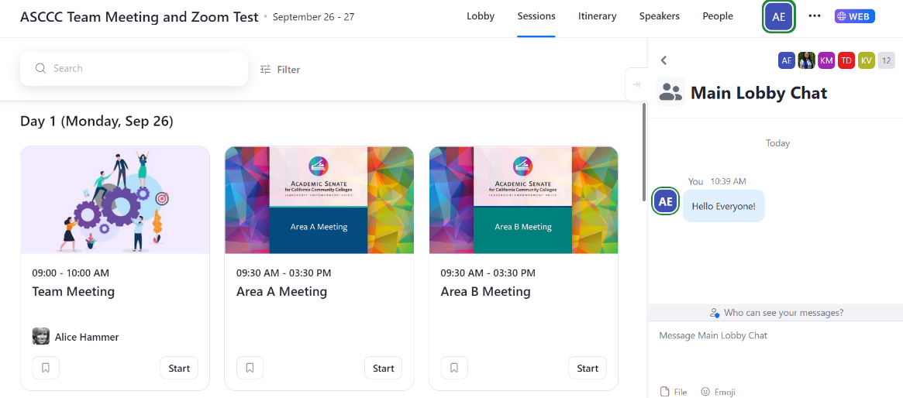
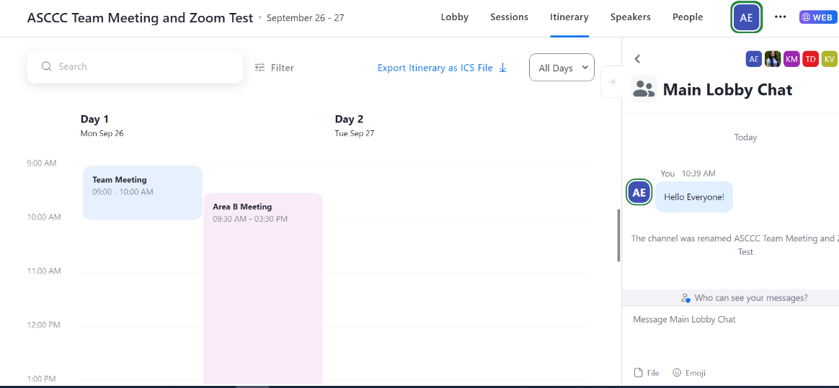

Joining a Session
- Speakers/Moderators can start the session by clicking on the start button. Attendees are only able to join once the Speakers/Moderators hit start and will be placed in the waiting room until the session is ready to start.
- Attendees can click on the “Join” button on the session page to get in.
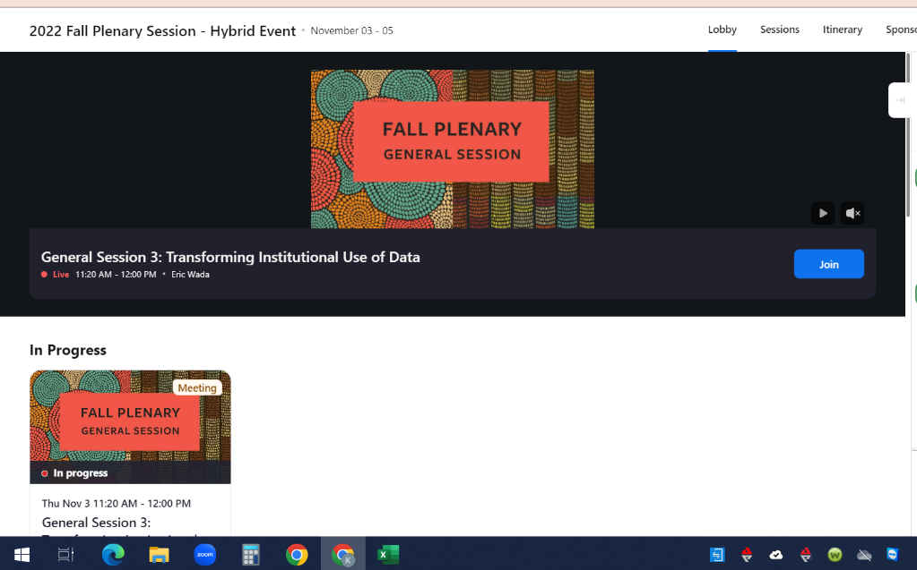

- When joining sessions, a pop up will occur asking to join through the app or stay on the web. You will then select to join through the app. If you opt to join sessions using your mobile device, you will be taken to the Zoom mobile app to navigate sessions.
- If you are not logged in to the session, you will receive a message asking you to log in the Zoom Account with the email address you’ve registered with. If you are not logged in to the correct email address, you will not have access to join the session.

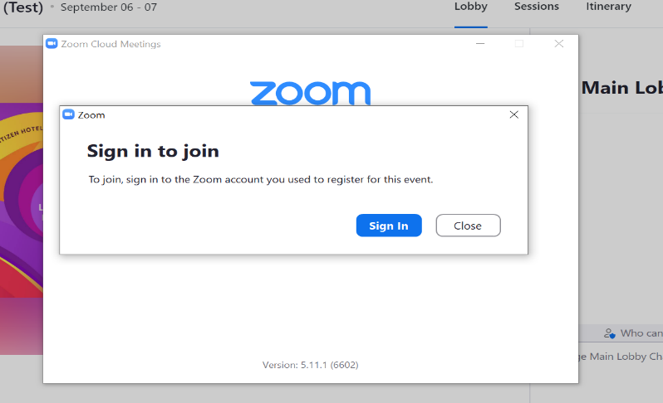

Change to the App version
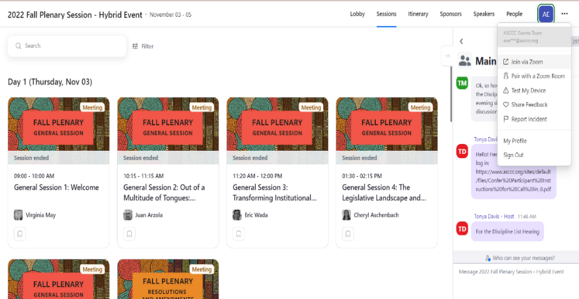
- For better viewing experience, you can join the event through the app. Click on the 3 dots ellipses to see more options and select “Join via Zoom”.
- A pop up will occur asking to open the zoom meeting. Check on the box that says, “Always allow events.zoom.us to open links of this type in the associates app” and click to Open Zoom Meetings.
