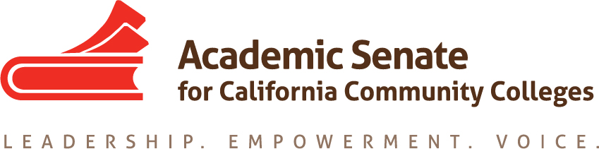

ASCCC PART-TIME COMMITTEE

October 18th, 2021 @3:30PM – 5:00PM

ZOOM

AGENDA

- Call to Order
  - Welcome
  - Notetaker
  - Attendance

- Adoption of the Agenda

- Approval of Minutes
  - 9.21.2021- approved by consensus via email

- ASCCC Information
  - ASCCC Part-Time Committee
  - ASCCC 2018 – 2023 Strategic Plan

- ASCCC Part-Time Committee Google Drive
  - Roster
  - Rostrums
  - Resolutions
  - Resources
  - Priorities/ Tasks
  - Part-Time Faculty Institute

- ASCCC Part-Time Committee Priorities/ Tasks
  - Committee Priorities
  - Committee Tasks

- ASCCC Part-Time Faculty Institute
  - February 10th – 11th, 2022 (virtual)
  - Program DRAFT- by November 3rd ASCCC Executive Committee meeting
  - Planning event date- TBD, virtual or in person
  - Breakout ideas, general sessions, presenters
  - Resource: 2021 Part-Time Faculty Institute PROGRAM

- ASCCC Updates
  - ASCCC Events
    - ASCCC Fall 2021 Plenary- "Leading Change: Teaching, Learning, and Governance in a Hybrid World"
Friday November 5th, 2:30 – 3:45 (virtual) Hot Topics for Part-Time Faculty
The ever-changing nature of higher education in California impacts part-time faculty both directly and indirectly. While our part-time faculty play a significant role in supporting our students in their educational endeavors, many statewide policies and local decisions turn into HOT TOPICS that impact the roles and responsibilities of part-timers, who are often left to deal with the fallout on their own. As the largest employed group at our colleges, it is imperative to learn how ​these colleagues play a significant and unique role in student success and contribute to college morale. Join this session for an engaging conversation about current and ongoing HOT TOPICS and discuss with us how colleges can better support their professional development and bolster their voices on campus… and beyond.

- Announcements/ Updates
  - Future meeting dates:
November 15th 4:00pm – 5:30pm
ZOOM

December 13th 4:00pm – 5:30pm
ZOOM

- Adjournment

Status of Previous Action Items

In Progress

Completed

FUTURE AGENDA ITEMS (TBD)

*ASCCC State of the System- ASCCC President/Vice President
*Legislation update
*Data on PT attendance at ASCCC events

