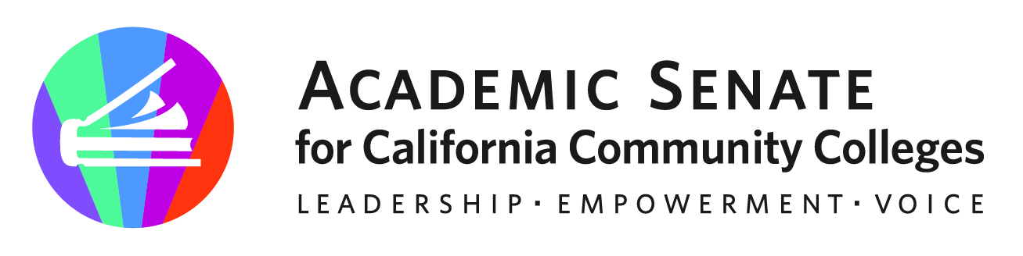

Accreditation Committee Meeting

Monday, November 14, 2022

Woodland Community College

2300 E Gibson Rd

Woodland, CA 95776

10:00 a.m.—3:00 p.m. (Lunch at 12pm)

Zoom Info for those not in person:
The Accreditation Committee advises the Academic Senate Executive Committee and statewide faculty on accreditation, continuous quality improvement, and equitable student learning. In collaboration with ACCJC, chief instructional officers, and other system partners, the committee organizes the Accreditation Institute and offers professional development opportunities with a focus on faculty roles and effective practices in accreditation. (updated June 4, 2021)
Join Zoom Meeting
https://laccd.zoom.us/j/82064516639
Meeting ID: 820 6451 6639
One tap mobile
+16699006833,82064516639# US (San Jose)
+16694449171,82064516639# US
Find your local number: https://laccd.zoom.us/u/ky8XohWLB

AGENDA

- Call to Order and Roll Call
Robert L Stewart Jr – 1st Chair | Dr. LaTonya Parker – 2nd | Randy Beach
Ricardo A. Castillo | Sharyn Eveland | Patricia Gomez
Lucy Giusto | Nghiem Thai | Kevin Bontenbal - ACCJC

- Land Acknowledgement - We begin today by acknowledging that we are holding our gathering on the land of the Nisenan Nations who have lived and continue to live here. We recognize the Nisenan Nations and their spiritual connection to the ocean and the land as the first stewards and the traditional caretakers of this area we now call Sacramento. As we begin, we thank them for their strength, perseverance, and resistance. We also wish to acknowledge the other Indigenous Peoples who now call Sacramento their home, for their shared struggle to maintain their cultures, languages, worldview and identities in our diverse City.

- Adoption of Agenda and Minutes from prior meeting (Consensus)

- Accreditation Committee Shared Google Folder 2022-2023

- Accreditation Committee Contact Information 2022-2023

- Fall 2022 Accreditation Coffee Breaks

  - November 16, 2022: 3-4pm; November 17, 2022: 4-5pm
https://www.asccc.org/events/accreditation-coffee-break

  - This Fall 2022, the ASCCC Accreditation Committee will facilitate a virtual space for faculty to dialogue and reflect on the Accreditation process, the faculty role in accreditation, the Accreditation Standards (Evolution of the Standards), how faculty see themselves and what they do in the Standards, and how local senates can assist in the institutionalization of processes that are supported by current Accreditation Standards.

  - Debrief October Coffee Break Sessions; Review material for November events and discuss facilitation of events. Facilitators for November 16, 2022: Robert, Ngheim, Lucy, Patty and Randy. Facilitators for November 17, 2022: Robert, Randy, LaTonya, Lucy, Ricardo and Patty.

- 2022-2023 ACCREDITATION COMMITTEE Goals and Priorities
  - Review ASCCC Strategic Plan for alignment of any goals and priorities (ongoing)
  - Continue Developing an Accreditation Committee Work Plan (ongoing)
    - Priorities (workload) and volunteers for activities: Discuss Resolutions adopted at Fall 2022 Plenary Session and consider any subsequent committee activities.
    - Rostrum Article Ideas and workgroups; Discuss and outline any ideas for Rostrum Articles – Upcoming Rostrum Deadlines: January 22, 2023; March 5, 2023
C. Review Charge for any possible updates in regards to IDEAA
D. Potential topics for Spring 2023 Regional Events/Coffee Break Events/Plenary:
    - Accreditation During Challenging Times (Regional Events)/Rostrum
– What is faculty role during these disruptions
Innovations – Regional/Rostrum
    - Credit for Prior Learning
    - Competency-Based Education
    - Microcredentialing
    - Ensuring Quality in the Comprehensive Review Process ( aka Formative Summative)
IDEAA/Social Justice
    - Regional Perspectives and Approaches to Disaggregating Data
    - Social Justice and Accreditation
    - Faculty Role in Accreditation
    - Formative/Summative
    - Other suggestions/ideas?

- Meeting Dates for Fall 2022
September 2, 2022: 4-5pm; Zoom
September 19, 2022: 1-3pm; Zoom
October 17, 2022: 1-3pm; Zoom
November 14, 2022: 10am-3pm; @ Woodland Community College (In person/Hybrid)
December 19, 2022: 1-3pm; Zoom

Meeting Dates for Spring 2022 - TBD

- Announcements
  - Check for upcoming events at here
- Spring 2023 Plenary Session – April 20, 2023; Anaheim, CA (hybrid)
  - Amazon Smile (smile.amazon.com)—select Foundation of the Academic Senate for California Community Colleges to donate
  - Application for Statewide Service

- Closing Comments
  - In Progress Review
  - Any other final comments or suggestions?

- Adjournment

In Progress

1. Fall 2022 Accreditation Coffee Breaks: November 16, 2022: 3-4pm; November 17, 2022: 4-5pm

Completed Tasks:

1. Resolution submitted: “Advocating for the Retention of a Library and Learning Resources and Support Services Substandard to the Accrediting Commission for Community and Junior Colleges Revised 2024 Accreditation Standards”. Contact Nghiem Thai – Adopted at ASCCC Fall 2022 Plenary Session. https://docs.google.com/document/d/1DVftnYE6P997TOYgk7IwNi26-nQkh9ef/edit#heading=h.gjdgxs

2. Rostrum Article: Increasing Access to Local Academic Senate Meetings Supports Inclusion, Diversity, Equity, and Social Justice Efforts. (Robert L Stewart Jr and Cheryl Aschenbach). For 9/18/2022 deadline. Published in November 2022 Rostrum. https://asccc.org/rostrum-reader/2022/November

3. Accreditation Coffee Breaks: October 18, 2022: 1-2pm; October 20, 2022 : 4-5pm

4. Fall Plenary Breakout Session with ACCJC on Updated 2024 Accreditation Standards; https://docs.google.com/presentation/d/1S2Sc8FROnyxbOonK2TlkylLJHrskKDq3/edit#slide=id.p1

