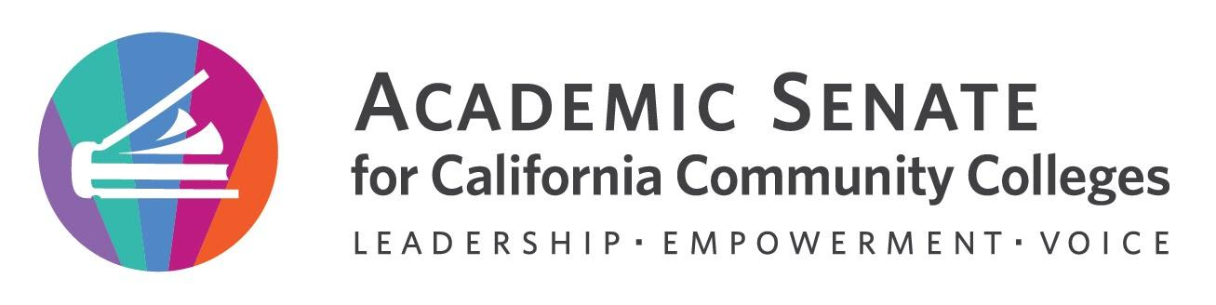

Online Education Committee

October 26, 2022

4:00-5:00pm

Zoom Link

Summary
Members: (*=present) *Amber Gillis (Chair), *Michelle Velasquez Bean (2nd), Monica Ambalal, *Jessica Bush, LaQuita Jones, *Bob Nash, *Benny Ng, Rebecca Orozco, *Michelle Pacansky-Brock, Mohamad Sharif-Idiris

- Welcome by the chair and check-in at 4:02 p.m.

- Adopt the agenda–approved by consent. M.Bean taking meeting notes.

- Review September 6, 2022 Meeting Summary–approved with no corrections.

- Discussion Items
  - @ONE Welcome and Coordination with ASCCC Efforts–B. Nash expressed strong interest in collaboration with ASCCC on professional development for the system and shared the @one website, including a review of the courses, the expert instructors, and the equity goals.
    - Committee members shared positive experiences in taking courses and the option of continuing ed units. M.P. Brock shared that two colleges have adopted the badging system for salary advancement.
    - M.Bean suggested leveraging work in DEI in curriculum to bring @one work into effective practices models.
    - M.P .Brock shared the community of practice model recently done with equitable grading.
    - Chair Gillis recommended continued Rostrum articles.
  - Online Education Position Paper Timeline–chair reviewed approval process and goals for completion of the paper.
    - Members suggested an additional section on hard to convert classes and also a shift in mindset toward asset-minded and culturally responsive practices.
    - Another suggestion is to provide a node to metaverse style for student interest and the flip classroom models.
  - Online Education Position Paper Section Assignments–members expressed desire for a cleaned-up version of the paper (i.e., accepting all the edits and comments).
  - Rostrum Ideas for 2023
    - Rostrum Editorial Guidelines
    - January 22, 2023
    - March 5, 2023

- Fall 2022 Meeting Schedule
    - November 16, 2022 at 4:00 p.m. confirmed– General Meeting + Writing Session
    - November 30, 2022 – Writing Session
    - December 8, 2022 at 4:00 p.m.--Amber sending a Doodle poll for confirmation - General Meeting + Writing

- Call for November 16, 2022 Agenda Items–send Amber an email with agenda items for December meeting.

- Adjournment At 5:10 p.m.

