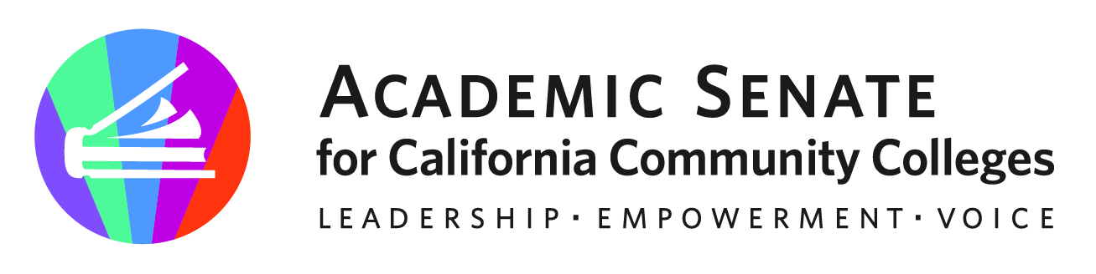

ASCCC Transfer, Articulation and Student Services Committee (TASSC)

January 9, 2023

Minutes

Attendees: Eric Wada, Stephanie Curry, Elizabeth Ramirez, Ty Simpson, Michelle Plug,

- Call to Order and Adoption of the Agenda
Meeting was called to order at 1:02pm.

- Review of November 2022 Meeting Minutes
Minutes from November 2022 meeting were approved by consensus

- Areas of Focus 2022-2023 (as assigned by the ASCCC President)
  - Partner with Transfer Alignment Project
  - General Education
  - Common course numbering
  - Reconsider role/utility of Guided Pathways Liaisons
    - Perhaps do a Rostrum Article

- Transfer Virtual Event in Spring 2023
Committee is planning for a Spring webinar on Planning for General Education and Transfer Changes on April 26 12:00-1:30pm. Stephanie will put in request to ASCCC for Feb Meeting.

- Resolutions Assigned from Fall 2022
Committee reviewed the new Resolutions assigned to the committee. Webinar Planned for April may address parts of 4.02 and 15.02
4.02 Proactive Planning and Support for Articulation and Counseling (1st Resolved)
7.10 Title 5 Regulations for Governing Catalog Rights (1st Resolved)
7.12 Re-evaluating the California promise Grant Regulations regarding Probation, Dismissal and Denial (1st Resolved)
15.02 Options for Transfer Students Enrolled Prior to the Implementation of CalGETC

- Resolutions for Spring Plenary
Proposing resolution on changing Academic Probation (title and processes)
Committee asked to bring additional resolution topics (as needed) to February Meeting

- Discussion regarding Guided Pathways Liaison
  - Rostrum- Idea for Rostrum about GP not getting lost in legislative initiatives

- Rostrums (Due January 20, 2023)
  - Probation
  - Guided Pathways
  - Counseling, Transfer and Dual Enrollment

- Assigned Resolutions
3.03 F21 Support for Mental Health Awareness and Trauma Informed Teaching and Learning
- Focus of ASCCC Academic Academy Spring 2022- Trauma Informed Leadership Practices in Education
9.01 S21 Develop a Set of Resources to Assist in Establishing Ethnic Studies Programs in Alignment with California State University Requirements

- Adjournment
The meeting adjourned at 1:57pm

Status of Previous Action Items

- In Progress (include details about pending items such as resolutions, papers, Rostrums, etc.)
- Rostrums
  - Probation
  - Guided Pathways
  - Counseling, Transfer and Duel Enrollment
- Resolutions
  - Probation
- Webinar- Planning for GE and Transfer Changes (April 26, 2023) 12-1:30pm

- Completed (include a list of those items that have been completed as a way to build the end of year report).
- GE Webinar Series Fall 2022
Date | Subject | # of Attendees
Monday, Sept 12, 2022 (9-10:30am) | General Education Requirements of the Associate Degree, Baccalaureate Degree, and Associate Degree for Transfer | 179
Tuesday, Sept 13 (3-4:30pm) | General Education Requirements of the Associate Degree, Baccalaureate Degree, and Associate Degree for Transfer | 150
Tuesday, Sept 27 (12-1:30pm) | Role of local Academic Senates and Curriculum Committees in regard to general education | 128
Wednesday, Sept 28 (2-3:30pm) | Role of Articulation in Transfer in regard to general education | 120
Monday Oct 3, 2022 (9-10:30am) | Addressing the impact of CalGETC, as proposed on local colleges, programs and course and students | 200
Thursday Oct 6, 2022 (2-3:30) | Addressing the impact of CalGETC, as proposed on local colleges, programs, courses and students | 128
 |  | 902 Total Duplicated Attendees
- Rostrum Article- The Articulation Officer’s Key Role in Curriculum, General Education and Transfer (November 2022)
- Approved Resolutions (Fall 2022)
  - 4.01 General Education in the California Community College System Resources
  - 4.02 F22 Proactive Planning and Support for Articulation and Counseling

