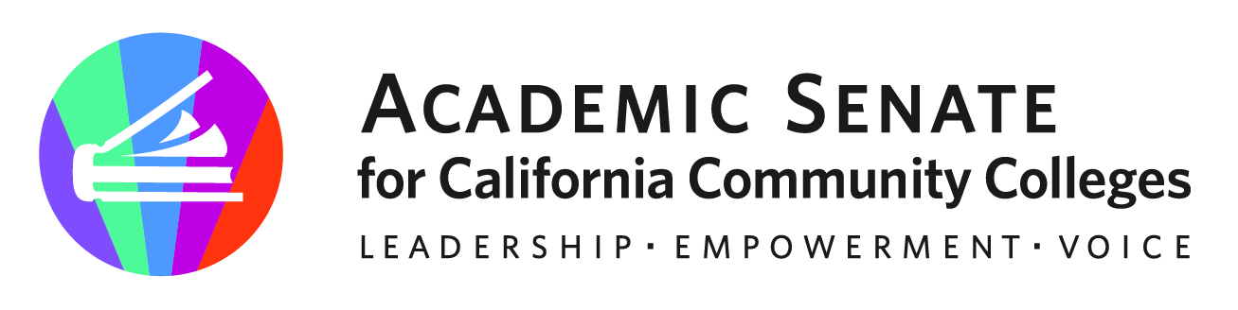

ASCCC Transfer, Articulation and Student Services Committee (TASSC)

May 8, 2023

MINUTES

- Call to Order and Adoption of the Agenda

- Areas of Focus 2022-2023 (as assigned by the ASCCC President)
  - Partner with Transfer Alignment Project
  - General Education
  - Common course numbering
  - Reconsider role/utility of Guided Pathways Liaisons

- Webinar Debrief – 109 Attendees, 187 Registered
  - Need to continue conversation next semester. Including areas of…
    - Confusion on Timelines of Ethnic Studies (Competencies and GE Courses)
    - Perhaps discussion or timeline on when things are due. Concerns that things are happening in multiple timelines
    - Align Title 5 changes with other GE changes
    - Need for additional supports for counseling and articulation over the next few years
    - List of compliance concerns. Need deadlines and timelines for CCC requirements and CSU/UC
    - Impact on catalogs and need for multiple catalog addendums
    - More subjectivity in CSU review only 2-3 reviews for UC. Extending timeline to 2 years. Will they allow CCCs to submit for IGETC and UC transfer at once?
    - Impact on CSU and potential alignment of CalGETC.
    - Students stuck in the middle of the changes. How can we support them

- Plenary Debrief
  - Part-Time faculty focus was appreciated. Good to expand inclusivity to part time faculty. Need to expand discussions to non-instructional part time faculty. Including making sure they are included in transfer and GE changes.

- Resolutions Assigned from Fall 2022
4.02 Proactive Planning and Support for Articulation and Counseling (1st Resolved)
7.10 Title 5 Regulations for Governing Catalog Rights (1st Resolved)
7.12 Re-evaluating the California promise Grant Regulations regarding Probation, Dismissal and Denial (1st Resolved)
15.02 Options for Transfer Students Enrolled Prior to the Implementation of Cal-GETC

- Assigned Resolutions
3.03 F21 Support for Mental Health Awareness and Trauma Informed Teaching and Learning
9.01 S21 Develop a Set of Resources to Assist in Establishing Ethnic Studies Programs in Alignment with California State University Requirements

- End of Year Report
  - Accomplishments
    - See below (action items)
  - Items for next year’s committee to consider
    - Communicate implementation dates on GE changes and clear deadlines
    - Resolution on CSU/UC submission dates/timelines and making them earlier for GE and Transfer articulations. Review in line with new GE processes and Cal-GETC.
    - Need information to field on potential Cal-GETC approval processes and professional development to support new processes.
    - Supporting students for catalog rights for students in between GE patterns (perhaps a webinar or Rostrum)- noting local differences
    - Continue work on resolution for Title 5 language on codifying catalog rights for students with flexibility (student-focused/asset-minded options) with local control on waiver options if needed.
    - Support for part-time counselors/articulation officers on all the GE and Ethnic Studies Changes. Perhaps work with Part-Time Committee
    - Professional Development on Catalog Rights (CTE, Local, and Transfer) for all (instruction and non-instructional faculty)
    - Support GE toolkit work in partnership with Curriculum Committee

- Other

- Adjournment

Status of Previous Action Items

- In Progress (include details about pending items such as resolutions, papers, Rostrums, etc.)

- Completed (include a list of those items that have been completed as a way to build the end of year report).
- GE Webinar Series Fall 2022
Date | Subject | # of Attendees
Monday, Sept 12, 2022 (9-10:30am) | General Education Requirements of the Associate Degree, Baccalaureate Degree, and Associate Degree for Transfer | 179
Tuesday, Sept 13 (3-4:30pm) | General Education Requirements of the Associate Degree, Baccalaureate Degree, and Associate Degree for Transfer | 150
Tuesday, Sept 27 (12-1:30pm) | Role of local Academic Senates and Curriculum Committees in regard to general education | 128
Wednesday, Sept 28 (2-3:30pm) | Role of Articulation in Transfer in regard to general education | 120
Monday Oct 3, 2022 (9-10:30am) | Addressing the impact of CalGETC, as proposed on local colleges, programs and course and students | 200
Thursday Oct 6, 2022 (2-3:30) | Addressing the impact of CalGETC, as proposed on local colleges, programs, courses and students | 128
 |  | 902 Total Duplicated Attendees
- Rostrum Article- The Articulation Officer’s Key Role in Curriculum, General Education and Transfer (November 2022)
- Rostrum Article- Addressing the Stigmatization of Academic Probation (February 2023)
- Approved Resolutions (Fall 2022)
  - 4.01 General Education in the California Community College System Resources
  - 4.02 F22 Proactive Planning and Support for Articulation and Counseling
- Webinar- Proactive Planning for General Education Changes (April 26, 2023) 109 Attendees and 187 Registered
- Approved Resolution (Spring 2023)
  - 7.01 S23 Destigmatize Academic Probation Language and Processes

